Flow Chart (kmsoftwares.com)

🏠 IT COMPANY HOME PAGE – COMPLETE BREAKDOWN

1 Hero Section (Top Section – Sabse Important)
Heading (Main Line):
We Build Scalable Digital Solutions for Your Business
Sub-Heading:
Web, Mobile & Software Development Services Tailored for Growth
Content:
- 1–2 lines company intro
- Trust badge / years of experience
- CTA Buttons
  - ✅ Get Free Consultation
  - ✅ View Our Work

2 Why Choose Us
Heading:
Why Choose Our Company(company name ) ?
Content (Icons ke saath):
- ✔ 10+ Years Industry Experience
- ✔ 100+ Projects Delivered
- ✔ Agile & Secure Development
- ✔ Dedicated Support Team

3 Services Section -> isme na services ke card banana hai or usme ek button dena hai Read more ka button lgana h tab jake jo abhi tumne expend me explain kr rkha h wow ala page wha particular service ka laga dena hai okk like

Heading: Our Services

🌐 Web Development
• Responsive & mobile-friendly websites
• Modern UI/UX design
• React / Angular / Vue based apps
• SEO-friendly development
• High performance & security
[ Read More ]

📱 Mobile App Development
• Android & iOS apps
• Flutter & React Native solutions
• Native app development
• Scalable & secure apps
• App Store & Play Store support
[ Read More ]

💻 Custom Software Development
• Business-specific solutions
• Scalable software architecture
• API & third-party integrations
• Secure & reliable systems
• Maintenance & support
[ Read More ]

Dedicated Team / Services
•Full-time dedicated developers
•Flexible hiring models: Hourly / Part-time / Full-time
•Team scales according to project requirements
•Expertise across multiple tech stacks
•Continuous support & maintenance

[ Read More ]

🤖 AI / Machine Learning
• Predictive analytics solutions
• Chatbots & automation
• Computer vision systems
• NLP-based applications
• Data-driven decision making
[ Read More ]

🛡 Cyber Security
• Application security testing
• Penetration testing
• Network security solutions
• Data protection & encryption
• Threat monitoring & prevention
[ Read More ]

☁ Cloud & DevOps
• AWS, Azure & GCP services
• Cloud migration
• CI/CD pipeline setup
• Docker & Kubernetes
• High availability & scalability
[ Read More ]

🤝 IT Consulting
• Technology strategy planning
• Digital transformation guidance
• System architecture consulting
• Cost & performance optimization
• Ongoing tech support
[ Read More ]

Short Content:
Har service ke niche 1 line description + Read More link

4️ Technologies We Expertise ( inme se sbke wo dal dena icon or jada hojaye toh slide me chlti rhengi )
Heading:
Our Technology Stack
Content:

Frontend (Beginner → Advanced)
• React.js
• Angular
• Vue.js
• Next.js

Backend (Beginner → Advanced)
• Python
• Node.js
• Java (Core Java)
• Flask
• Django
• Spring Boot

Mobile App Development (Beginner → Advanced)
• Android (Java)
• Android (Kotlin)
• iOS (Swift)
• Flutter (iOS & Android)
• React Native (iOS & Android)

Database (Beginner → Advanced)
• MySQL
• MongoDB
• PostgreSQL
• Firebase

Cloud & DevOps (Beginner → Advanced)
• Git & GitHub
• AWS
• Microsoft Azure
• Google Cloud Platform
• Docker
• Kubernetes
• CI/CD (Jenkins, GitHub Actions)

AI / Machine Learning (Beginner → Advanced)
• Python
• NumPy
• Pandas
• Scikit-learn
• TensorFlow
• Keras
• PyTorch
• OpenCV
• NLP (NLTK, SpaCy)

Cyber Security (Beginner → Advanced)
• Networking Basics
• Linux Fundamentals
• Ethical Hacking
• Web Application Security
• Penetration Testing
• Kali Linux
• Metasploit
• Wireshark
• Burp Suite
• SIEM Tools
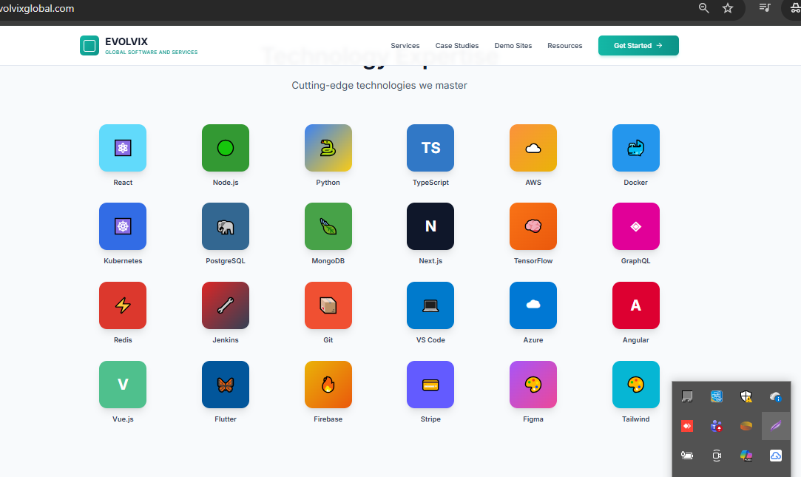

5️Our Process (How We Work) (
Heading:
Our Development Process
Steps:
1️Requirement Analysis
2️ UI / UX Design
3️ Development
4️ Testing & QA
5️ Deployment
6️ Support & Maintenance

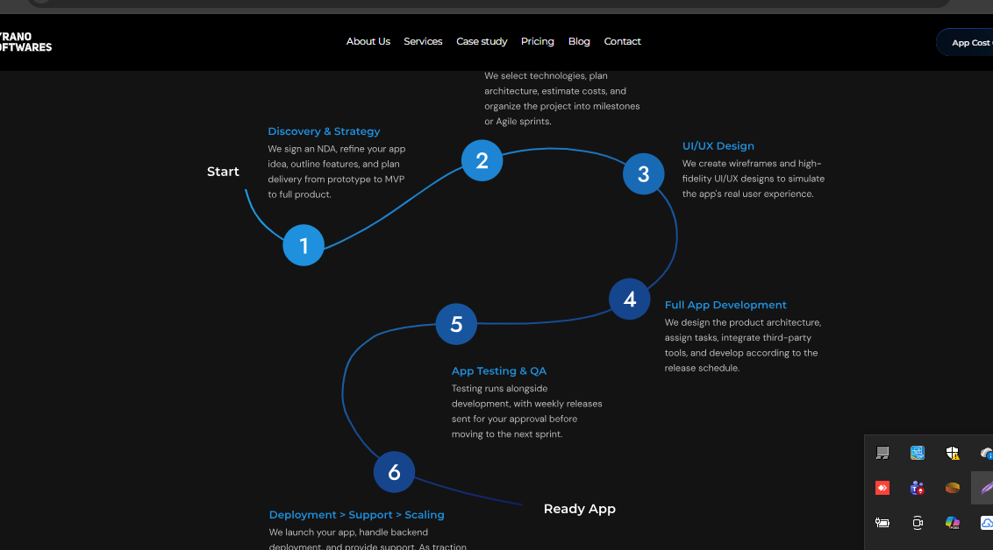

6️Portfolio / Case Studies Preview ( ABhi isko Skip kr skte hai but bana ke rkh lena bad me )
Heading:
Our Work Speaks for Itself
Content:
- 3–6 project thumbnails
- Project name + industry
- View Case Study button

7 Client Testimonials
Heading:
What Our Clients Say
Content:
- Client photo
- Short review
- Company name & role

8️Industries We Serve
Heading:
Industries We Serve
Content (Icons):

Industries / Domains IT Companies Work In (AI/Ml, Cybersecu wala
• Healthcare
• FinTech
• E-Commerce
• Education (EdTech)
• Real Estate (PropTech)
• Logistics & Supply Chain
More Industries 👇
• Banking & Financial Services (BFSI)
• Insurance (InsurTech)
• Travel & Hospitality
• Media & Entertainment
• Retail
• Manufacturing
• Automotive
• Telecom
• Energy & Utilities
• Agriculture (AgriTech)
• Government & Public Sector
• Smart Cities
• Sports & Fitness
• Food & Restaurant (FoodTech)
• Human Resources (HRTech)
• Marketing & Advertising (MarTech)
• Cyber Security
• Gaming
• AI & Data Analytics
• Blockchain & Web3
• IoT (Internet of Things)
• SaaS Products
Note :- Industry ko aise chote chote card usme rkhna
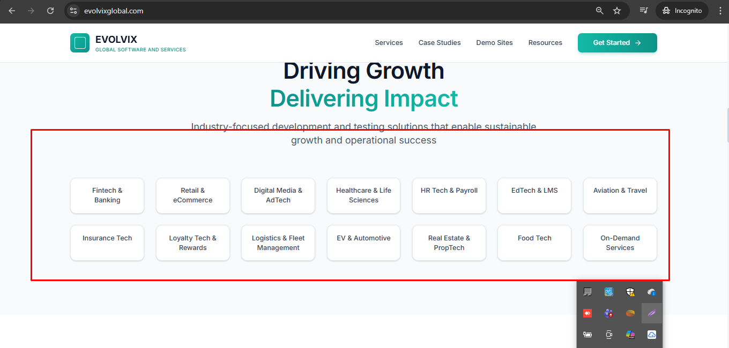
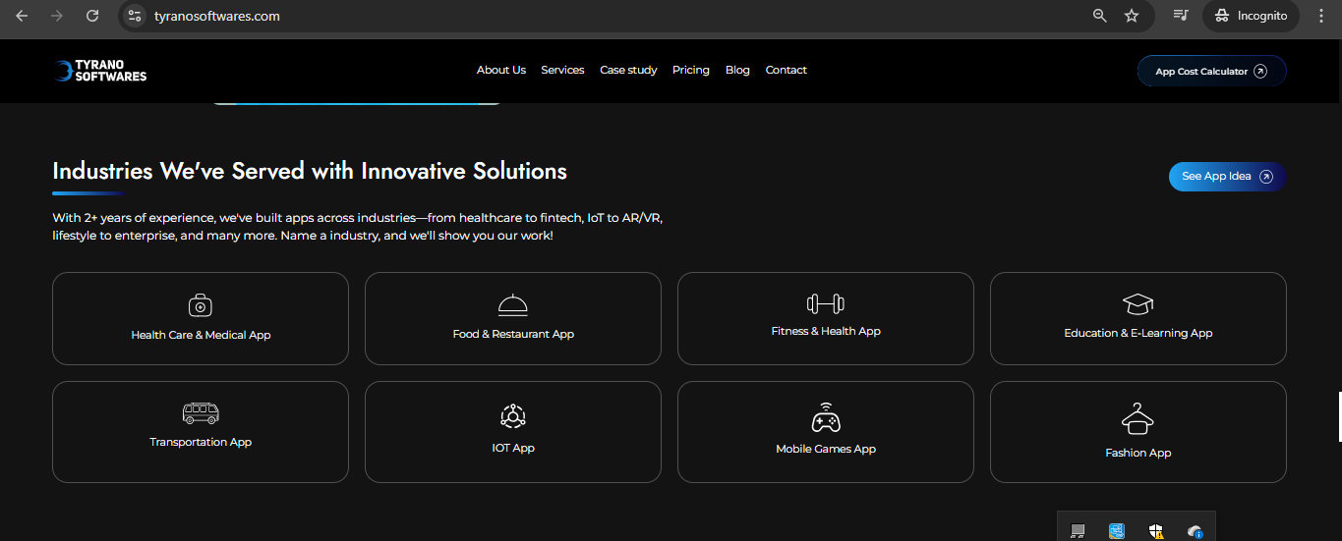

9️ Call to Action (Lead Section) ( Get a Quote wala section rkhna ) footer se upper
Heading:
Let’s Build Something Great Together
Content:
- 1 line pitch
- CTA Button
  - 📞 Contact Us Today
  - 📧 Request a Quote

🔟 Footer Preview (Bottom Teaser)
Content:
- Office locations
- Email / Phone
- Social media icons
- Trust badges

🔑 Pro Tips (Jo Acchi IT Companies Zaroor Follow Karti Hain)
✔ Clear messaging (zyada text nahi)
✔ Strong CTA buttons
✔ Real projects & real testimonials
✔ Fast loading & clean UI
✔ Mobile-first design

